- Non critical with update ship to only or ability to create new ship to / update open documents. “Update current Ship To only” is correct as the first and default option in the case where the field on the ship to that was modified is not the address, but is a field that is common with the document header and, as such, is synchronized. Examples, Territory, Cust Acct Set, Price List, Sales Rep, Ship Via, Ship Terms.
I suggest changing “Update current Ship To only” to “Update current Ship To and current document only.” This would update the Ship To and the document the ship to maintenance form was opened from.
I think that we can now modify the second option by removing “Choose to create a new Ship To or” part of the caption. It does not make sense to create a new ship to with the same address, but the Price List is different (as an example). I suggest that the second option be changed to “Update all open documents for this Ship To with the updated Ship To information.” This way, users will not be able to create multiple ship tos with the same address as easily and can better control how fields that are shared between the document header and the ship to are updated.
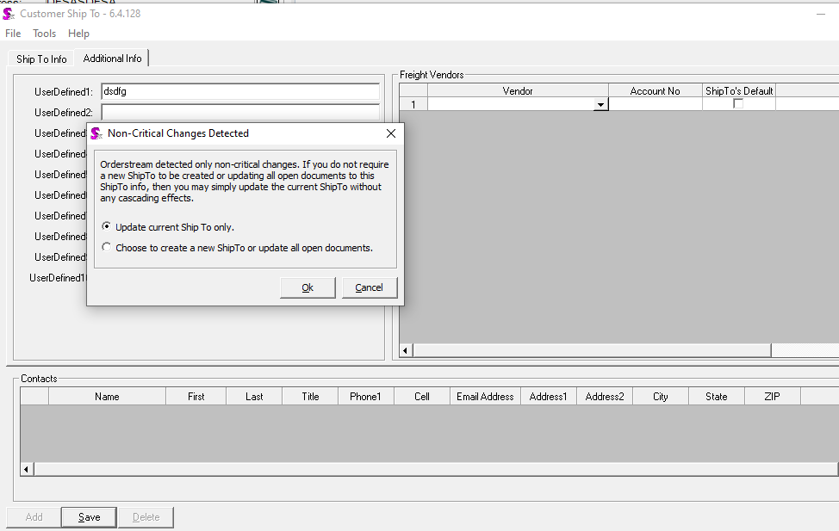
- Critical with ability to create new ship to or update open documents. This message should only be displayed when the address is changed (i.e. Address L1, L2, L3, L4, City, StateProv, PostalCode). Change the sequence so that update open documents is the first and default option. Change the wording to “Update all open documents for this Ship To with the updated Ship To information.” Relegate “create new ship to” to second position.
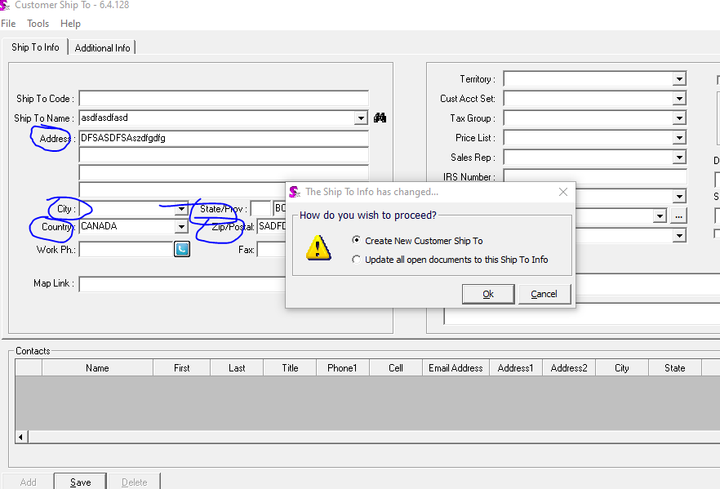

- Updating ship to only, but with incorrect caption on message. The caption is misleading as, in this case, I updated Notes 1. Notes 1 is not stored against the document, thus there can be no open documents to update… only the ship to will be updated. The caption here should be “Update current Ship To only.” This message should be displayed when the field on the ship to that has been changed is not the address and is not a field that is also on the document header (and, as such, is synchronized). Alternatively we could just show a message after save to indicate that “The Ship To has been saved” or something like that, as there really is no decision that the user needs to make.
